Complex word

🟣 What is a Complex Word?
# Source: AI Source: Provided by: [Data Path: Persons Table -> ID Column: 1, Name_En Column: Motasem Essam] -> From: [Chatgpt (GPT-4-turbo)] on [7/24/2025]
A complex word is a word that consists of a root (or base word) and one or more affixes (prefixes or suffixes).
It is not simple because it has multiple morphemes, but it’s also not a compound (which joins two full words).

📘 Definition:
# Source: AI Source: Provided by: [Data Path: Persons Table -> ID Column: 1, Name_En Column: Motasem Essam] -> From: [Chatgpt (GPT-4-turbo)] on [7/24/2025]
A complex word is a word made from a base/root word plus at least one affix, such as a prefix, suffix, or both.

🧠 Examples of Complex Words:
# Source: AI Source: Provided by: [Data Path: Persons Table -> ID Column: 1, Name_En Column: Motasem Essam] -> From: [Chatgpt (GPT-4-turbo)] on [7/24/2025]
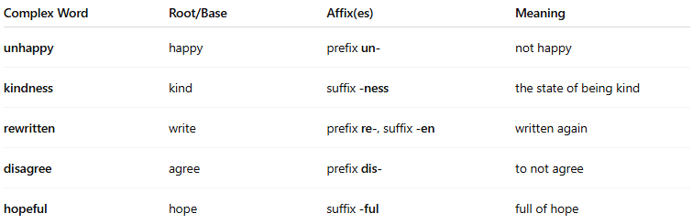
Complex Word | Root/Base | Affix(es) | Meaning
unhappy | happy | prefix un- | not happy
kindness | kind | suffix -ness | the state of being kind
rewritten | write | prefix re-, suffix -en | written again
disagree | agree | prefix dis- | to not agree
hopeful | hope | suffix -ful | full of hope

🧩 Structure of Complex Words:
# Source: AI Source: Provided by: [Data Path: Persons Table -> ID Column: 1, Name_En Column: Motasem Essam] -> From: [Chatgpt (GPT-4-turbo)] on [7/24/2025]
- Prefix + Root → un+do = undo
- Root + Suffix → care+ful = careful
- Prefix + Root + Suffix → un+kind+ly = unkindly

🆚 Comparison:
# Source: AI Source: Provided by: [Data Path: Persons Table -> ID Column: 1, Name_En Column: Motasem Essam] -> From: [Chatgpt (GPT-4-turbo)] on [7/24/2025]
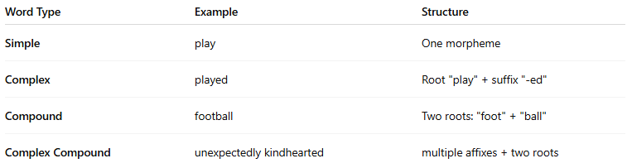
Word Type | Example | Structure
Simple | play | One morpheme
Complex | played | Root "play" + suffix "-ed"
Compound | football | Two roots: "foot" + "ball"
Complex Compound | unexpectedly kindhearted | multiple affixes + two roots

complex word vs compound word
# Source: AI Source: Provided by: [Data Path: Persons Table -> ID Column: 1, Name_En Column: Motasem Essam] -> From: [Chatgpt (GPT-4-turbo)] on [7/24/2025]
Great question! Here's a clear comparison between complex words and compound words:

🔹 Compound Word
# Source: AI Source: Provided by: [Data Path: Persons Table -> ID Column: 1, Name_En Column: Motasem Essam] -> From: [Chatgpt (GPT-4-turbo)] on [7/24/2025]
Definition: A word formed by joining two or more free morphemes (each can stand alone as a word).
Structure:
Free morpheme + Free morpheme (or more)
Examples:
- toothbrush = tooth + brush
- notebook = note + book
- blackboard = black + board
🟢 Each part can exist alone as a word.

🔹 Complex Word
# Source: AI Source: Provided by: [Data Path: Persons Table -> ID Column: 1, Name_En Column: Motasem Essam] -> From: [Chatgpt (GPT-4-turbo)] on [7/24/2025]
Definition: A word made up of a root + one or more affixes (prefixes or suffixes).
It contains a bound morpheme (which cannot stand alone).
Structure:
Root + Affix (prefix or suffix)
Examples:
- unhappy = un- (prefix) + happy
- teacher = teach + -er (suffix)
- rewrite = re- (prefix) + write
🟢 At least one part (the affix) cannot stand alone.

🔸 Key Differences:
# Source: AI Source: Provided by: [Data Path: Persons Table -> ID Column: 1, Name_En Column: Motasem Essam] -> From: [Chatgpt (GPT-4-turbo)] on [7/24/2025]
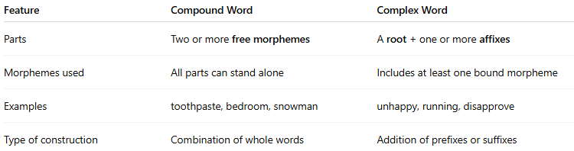
Feature | Compound Word | Complex Word
Parts | Two or more free morphemes | A root + one or more affixes
Morphemes used | All parts can stand alone | Includes at least one bound morpheme
Examples | toothpaste, bedroom, snowman | unhappy, running, disapprove
Type of construction | Combination of whole words | Addition of prefixes or suffixes

✅ Tip to Remember:
# Source: AI Source: Provided by: [Data Path: Persons Table -> ID Column: 1, Name_En Column: Motasem Essam] -> From: [Chatgpt (GPT-4-turbo)] on [7/24/2025]
- Compound = “word + word”
- Complex = “word + piece” (prefix/suffix)
Let me know if you'd like a quiz or practice on this!

✅ Summary:
# Source: AI Source: Provided by: [Data Path: Persons Table -> ID Column: 1, Name_En Column: Motasem Essam] -> From: [Chatgpt (GPT-4-turbo)] on [7/24/2025]
A complex word is a word made by adding prefixes and/or suffixes to a root.
It contains more than one morpheme, but not multiple full words like a compound word.

